To: | Erin Daughton, ComEd
CC: | Jennifer Morris, ICC Staff; Jeff Erickson, Rob Neumann, Laura Agapay-Read, Guidehouse
From: | Jennifer Fagan and Kumar Chittory, Verdant Associates
Date: | July 21, 2021
Re: | Net-to-Gross Research Results for the ComEd Custom Program and Data Centers Subprogram

Executive Summary
This memo presents the findings from the net-to-gross (NTG) study of the ComEd Custom program, which includes regular Custom projects and Data Center projects. The latter category results from the conversion of the Data Centers program from a standalone program into a component of the Custom program on January 1, 2019. The NTG calculations rely on the NTG algorithms agreed to by the Illinois Stakeholder Advisory Group (SAG) Nonresidential Net-to-Gross Working Group earlier this year and use the self-report approach for estimating free ridership and spillover. These results will inform Guidehouse’s September 2021 draft recommendations to the Illinois SAG of NTG values to be used for this program in CY2022.
Findings are based on in-depth telephone interviews with customers who participated in the program in CY2020. The interviews researched free ridership (FR) and spillover (SO) effects. For Custom projects, the NTG findings are based on the results of in-depth interviews completed on 19 projects representing 55% of the ex ante savings from the population of 184 Custom projects. For Data Center projects, in-depth interviews were completed on eight projects encompassing 65% of the ex ante savings from the population of 16 Data Center projects.
Table 1 and Table 2 present the NTG research results for Custom and Data Center projects, respectively.
- For Custom projects, as Table 1 shows, the energy NTG ratio from the new FR research is 0.36. LED Streetlights had a NTG ratio of 0.81 which is based on research completed in the CY2018 evaluation cycle. For Custom and Streetlighting projects combined, the energy NTG ratio is 0.40. This is similar to the NTG research results from the CY2019 evaluation cycle, which had a program-level energy NTG ratio of 0.43. Our spillover research found none; therefore, the participant spillover rate is 0.00.
Table 1. Net-to-Gross Research Results for ComEd Custom Projects CY2020
Measure | Savings Type | Free Ridership | Relative Precision at 90% CI | Participant Spillover | NTG Ratio
Custom Projects | kWh | 0.64 | 13% | 0.00 | 0.36
Custom Projects | kW | 0.74 | 16% | 0.00 | 0.26
LED Streetlighting | kWh | 0.19 | N/A | 0.00 | 0.81
LED Streetlighting | kW | 0.19 | N/A | 0.00 | 0.81
Custom and Streetlighting | kWh | 0.60 | 10% | 0.00 | 0.40
Custom and Streetlighting | kW | 0.74 | 16% | 0.00 | 0.26
Source: Evaluation team analysis
- For Data Center projects, as Table 2 shows, the new energy NTG ratio from FR research is 0.44. This is lower than the energy NTG ratio of 0.50, currently in effect for CY2021. The savings weighted energy NTG ratios for new construction and retrofit projects are 0.46 and 0.38, respectively. The team did not stratify the results by co-location projects as there were not enough non-co-location projects in the CY2020 population to support separate estimates.
Table 2. Net-to-Gross Research Results for ComEd Data Centers Projects
Measure | Savings Type | Free Ridership | Relative Precision at 90% CI | Participant Spillover | NTG ratio
New Construction | kWh | 0.54 | 33% | 0.00 | 0.46
New Construction | kW | 0.25 | 9% | 0.00 | 0.75
Retrofit | kWh | 0.62 | 47% | 0.00 | 0.38
Retrofit | kW | 0.70 | 50% | 0.00 | 0.30
Data Centers Component | kWh | 0.56 | 26% | 0.00 | 0.44
Data Centers Component | kW | 0.48 | 18% | 0.00 | 0.52
Source: Evaluation team analysis

Free Ridership and Spillover Research Representation
The evaluation team conducted in-depth telephone interviews with key decision makers for each sampled project. For CY2020 Custom projects, 20 interviews were completed, and for CY2020 Data Center projects, eight interviews were conducted. The interview guides followed the standard NTG question structure and the in-depth format allowed for flexibility, follow-up probing, and consistency checking. Table 3 reports survey representation for free ridership and spillover question batteries for Custom and Data Center projects.
Table 3. Custom Projects Free Ridership and Spillover Research Representation
Project Type | Population | Target Completes | Actual Completes | Analyzed Completes* | Share of Program Savings Represented by Analyzed Completes | Qualified for Spillover
Custom | 184 | 20 | 20 | 19 | 41% | 0
Data Center | 16 | 8 | 8 | 8 | 65% | 0
* Analyzed completes is the count of responses used to develop the free ridership and spillover estimates. It excludes responses that failed consistency checks or lacked required data.
Source: Evaluation team analysis

Free Ridership and Spillover Protocols
The evaluation team applied the relevant free ridership and spillover protocols agreed to by the Illinois Nonresidential Net-to-Gross Working Group earlier this year.

Participant Free Ridership Estimation
Figure 1 describes the Illinois SAG NTG Working Group algorithm that Guidehouse used to calculate the FR for Custom and Data Centers projects. The questions and analysis are based on the TRM v9.0 Core Non-Residential Free Ridership algorithm, with updates based on the Illinois SAG NTG Working Group consensus in 2020.

Figure 1. Custom and Data Centers Free Ridership Overview
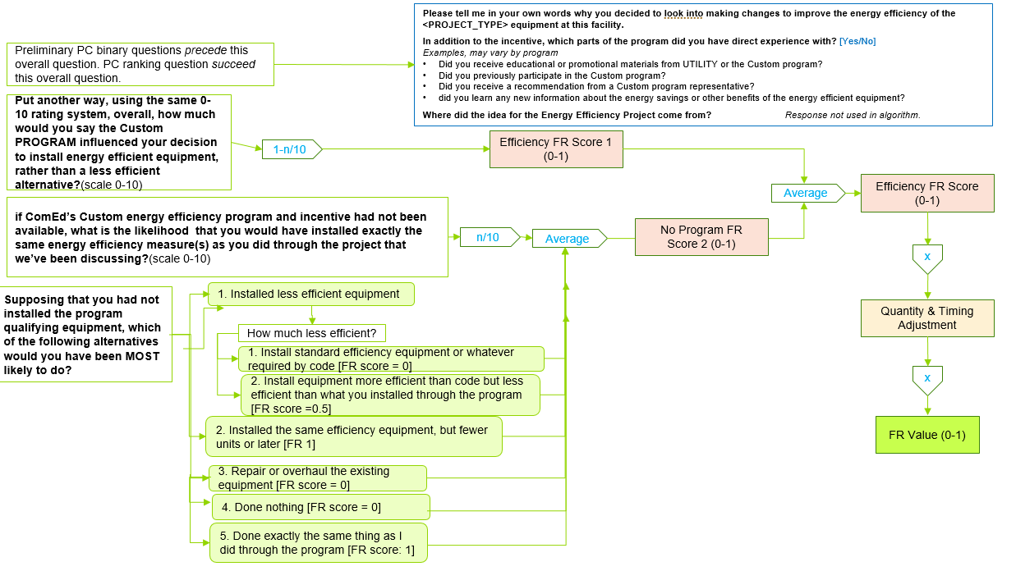

Source: Based on Illinois Nonresidential NTG Working Group consensus algorithms for the 2020 evaluation.
Figure 2. Quantity and Timing Adjustment
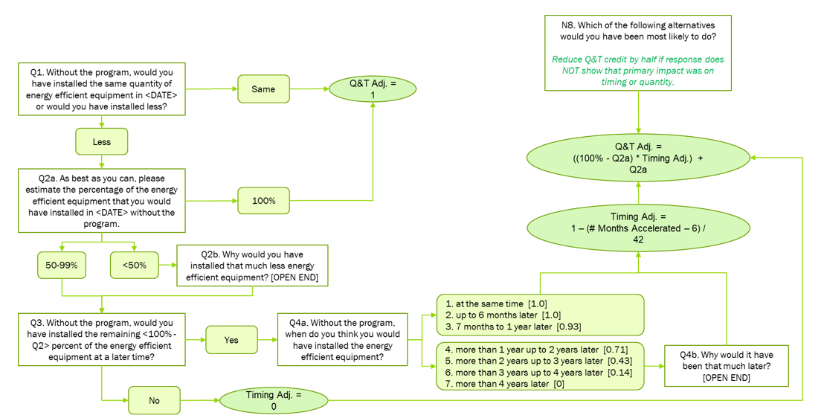

Source: Based on Illinois Nonresidential NTG Working Group consensus algorithms for the 2020 evaluation.

Participant Spillover Estimation
The evaluation team used the Core Participant Spillover protocol as specified in Illinois TRM v9.0 to qualify non-rebated energy efficiency improvements as SO. This protocol is applicable to most commercial, industrial, and public sector programs. Figure 3 illustrates the spillover qualification screening process for the Custom and Data Center program projects.
Figure 3. Core Non-Residential Participant Spillover Protocol from TRM v9.0
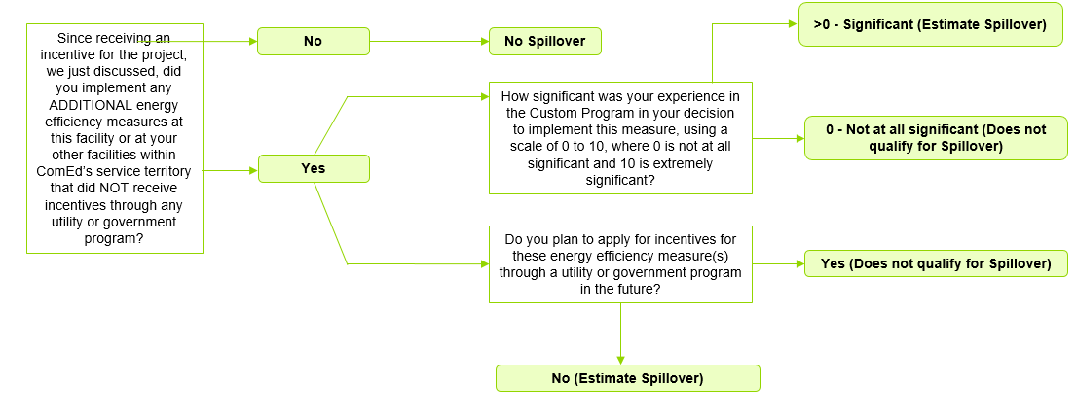

Source: Evaluation team representation of TRM v9.0

Detailed Free Ridership Results

Custom Projects
Table 4 summarizes FR findings for Custom projects across the three sampling size strata. Stratum 1 represents the largest projects, Stratum 2 consists of medium-sized projects, and Stratum 3 contains the smallest projects.
Table 4. Custom Projects Breakdown by Sampling Strata
Sampling Stratum | Number of Projects in Sample | Ex Ante kWh in Sample | Ex Ante kWh in Population | Percent of Savings | FR
Stratum 1 – Large Projects | 5 | 11,995,906 | 11,995,906 | 100% | 0.50
Stratum 2 – Medium Projects | 7 | 4,199,702 | 8,590,847 | 49% | 0.57
Stratum 3 – Small Projects | 7 | 529,402 | 9,882,798 | 5% | 0.83
All Custom Projects | 19 | 16,725,010 | 30,469,550 | 55% | 0.64
Source: Evaluation team analysis
The savings weighted energy FR across all Custom projects, excluding LED Streetlighting, was 0.64, indicating a low level of program influence. Free ridership for Custom projects has been high since PY9 (Figure 4 shows the FR for Custom projects since PY2). The high-level of FR for Custom projects included in this study was driven by several large and medium legacy projects with high FR that originated in CY2019 and continued into CY2020, and a number of small LED lighting projects that respondents reported were standard practice.
- The four evaluated projects in Stratum 1 had FR that ranged from 0.25 to 0.63. This Stratum also includes a Streetlighting project that was not evaluated as part of this study.
  - For two projects with high FR (0.63), the project’s favorable economics met the customer’s payback threshold without the incentive.
  - Two Stratum 1 projects had lower FR (0.25 and 0.47). The respondent for one project reported that the incentive was key and the project would not have happened without it due to poor project economics. For the second project, the age and condition of the old equipment were key drivers. The existing equipment was cheaply made and failing. Without the program, the customer would have likely installed something above code, but less efficient than the program measure.
- The seven evaluated Stratum 2 projects had FR that ranged from 0.20 to 0.95.
  - The project with high energy savings was a legacy project with a high FR (0.87). This was a legacy project where the decision maker reported that the installed energy efficiency measure was the only reasonable option for them.
  - One Stratum 2 project with the lowest FR (0.20) reported that the incentive was key and without it, the project would not have qualified for capital within their corporation.
  - Three Stratum 2 projects with moderate FR (0.47, 0.40 and 0.38) indicated that while program factors were somewhat important, corporate sustainability policy and standard practice were the key drivers.
  - The project with the highest FR (0.95) installed energy efficient lighting at a new facility and LEDs are standard for their new construction.
- The seven evaluated Stratum 3 projects had FR that ranged from 0.25 to 1.
  - Two large projects within Stratum 3 had FR of 0.9 and 1, which pulled down the weighted NTG ratio across the stratum. For one project, program factors were reportedly irrelevant to their decision as the key drivers were corporate policy and industry standard practice. The other project was a lighting project with very low program influence.
  - Three of the seven Stratum 3 projects involved the installation of LED lighting. FR for these projects were generally high as respondents reported LEDs were standard practice.
  - For three Stratum 3 projects, FR ranged from 0.33 to 0.63 as survey respondents ranked the program incentive as moderate.

Data Center Projects
Table 5 summarizes FR results for Data Center projects across the three sampling strata.
Table 5. Data Center Project Breakdown by Sampling Strata
Sampling Stratum | Number of Projects | Ex Ante kWh in Sample | Ex Ante kWh in Population | Percent of Savings | FR
Stratum 1 – Large Projects | 3 | 3,624,895 | 3,624,895 | 100% | 0.76
Stratum 2 – Medium Projects | 2 | 1,921,453 | 3,828,929 | 50% | 0.47
Stratum 3 – Small Projects | 3 | 1,521,757 | 3,354,473 | 45% | 0.44
All Data Center Projects | 8 | 7,068,105 | 10,808,296 | 65% | 0.56
Source: Evaluation team analysis
Overall, the Data Center FR of 0.56 is higher than the value in effect for CY2021 of 0.50. In this report, FR values are reported separately for retrofit projects and new construction projects. Compared to previous values, the new energy FR values are higher for retrofit projects (0.56 in new research versus 0.25 in previous research) and lower for new construction projects (0.44 in the new research versus 0.57 in previous research). For this program year, there were not enough non-co-location projects in the population, so they were not stratified separately.
- The Stratum 1 category included three evaluated projects:
  - One Stratum 1 retrofit project yielded a high energy FR of 0.85. Non-energy automation benefits were the key motivating factor for the project and the company would have installed the same energy efficiency equipment at the same time without the incentive from ComEd.
  - For a Stratum 1 new data center, the data center would have been built to be energy efficient regardless of whether the program and incentive were available. The incentives were important but having a property to develop the market need for a data center drives the process to build. The project’s FR of 0.83 reflects this attribution.
  - The third Stratum 1 project was also for a new data center that reported moderate program influence (FR was equal to 0.6).
- The Stratum 2 category had two medium-sized retrofit projects that exhibited medium and strong program influence levels, respectively:
  - For one project, the company would have delayed the installation of the new equipment by 4 to 5 years in the absence of the incentive, resulting in a low level of free ridership (0.23).
  - For the second project the program incentive was of moderate importance in helping the customer meet their payback threshold and the project was implemented due to the success of a similar project done at a different location, leading to high free ridership of 0.75.
- All three Stratum 3 projects in the sample were new construction projects and had FR ranging from 0.17 to 0.75. Two of the three projects in this stratum were legacy projects that received a phased payment in CY2020 for projects originally started and evaluated during a previous evaluation cycle.
Table 6 summarizes the key contextual factors for Custom and Data Center projects with high free ridership. Among large- and medium-sized projects, the factors correlated with high free ridership are the need to replace old equipment, common industry practice for selecting new equipment, or both. Small projects have somewhat different non-program motivations that include corporate policies and their previous equipment with the same measure at another location.
Table 6. Factors Contributing to High Free Ridership
Factor | Large Projects | Medium Projects | Small Projects
Selection of efficient options when replacing old, obsolete equipment | X | X
Efficient options are industry standard practice | X | X
Automation benefits |  | X
Standard lighting practice for new construction |  | X | X
Corporate policy or guidelines |  |  | X
Previous experience with same equipment |  |  | X
Source: Evaluation team analysis
Based on the information collected from the phone interviews, none of the CY2020 participants reported improvements that qualified as spillover. The evaluated Custom or Data Center projects did not report non-rebated energy efficiency improvements that the programs sufficiently influenced; thus, the spillover savings are zero. The rate of spillover incorporated into the NTG ratios is zero.

Final NTG Results and Recommendations
Table 7 summarizes Guidehouse’s draft recommendations for the Custom program to be used in CY2022 based on the new NTG research. NTG ratios are reported separately for the Custom projects and LED Streetlighting projects. The LED Streetlighting projects are unique large projects that merit separate reporting and the result based on research completed in the CY2018 evaluation cycle for the LED Streetlighting Program.
Table 7. Summary of Free Ridership, Spillover and NTG Research Results for the Custom Program
Measure | Savings Type | Free Ridership | Spillover | NTG Ratio
Custom Projects | kWh | 0.64 | 0.00 | 0.36
Custom Projects | kW | 0.74 | 0.00 | 0.26
LED Streetlighting | kWh | 0.19 | 0.00 | 0.81
LED Streetlighting | kW | 0.19 | 0.00 | 0.81
Source: Evaluation team analysis

- Table 8 summarizes Guidehouse’s recommendations for the Data Center projects to be used in CY2022 based on the new NTG research results. The team estimated separate NTG ratios for new construction and retrofit projects. Unlike previous years, the team did not stratify the results by co-location projects as there were not enough non-co-location projects in the CY2020 population to support separate estimates.
Table 8. Summary of Free Ridership, Spillover and NTG Research Results for the Custom Program
Measure | Savings Type | Free Ridership | Spillover | NTG Ratio
New Construction | kWh | 0.54 | 0.00 | 0.46
New Construction | kW | 0.25 | 0.00 | 0.75
Retrofit | kWh | 0.62 | 0.00 | 0.38
Retrofit | kW | 0.70 | 0.00 | 0.30
Source: Evaluation team analysis

Recommendations to Reduce Free Ridership
Free ridership in the nonresidential Custom market is challenging to address due to the large size of the participating companies, the end use customers’ and suppliers’ high degree of sophistication in energy-use decision-making, and the complexity of projects. As a result, a fair amount of free ridership is expected in this market. Despite these challenges, there are several strategies available to ComEd to adjust program design elements and implementation procedures to reduce free ridership, which has been incorporated into the recommendation below:
Recommendation: Adopt procedures to limit free riders or convert them to non-free riders with higher efficiency projects.
ComEd can accomplish this by conducting screening for high free ridership on a project-by-project basis. Where free ridership is found, the program implementer should continue and expand their current pre-approval process to provide more explicit consideration and reformulation of projects already planned for completion by the customer.
The program could also increase the efficiency standard for incentive eligibility across the board so all projects must meet a higher level of efficiency to qualify.
Neither of these options equates to rejecting a customer for energy efficiency funding. Instead, the concept is to upsell the customer to an energy efficiency project they were not already planning to complete on their own.
As Figure 4 shows, Custom project FR fluctuated between 0.28 and 0.44 since the program began until PY9 when the FR value increased to 0.55 (and 0.56 in CY2018). The current FR of 0.60 reflects relative stability in this value since PY9. The consistently high FR since PY9 suggests that an approach is warranted to reducing free ridership.
Figure 4. Comparison of Custom Project Evaluated Free Ridership over Program Years
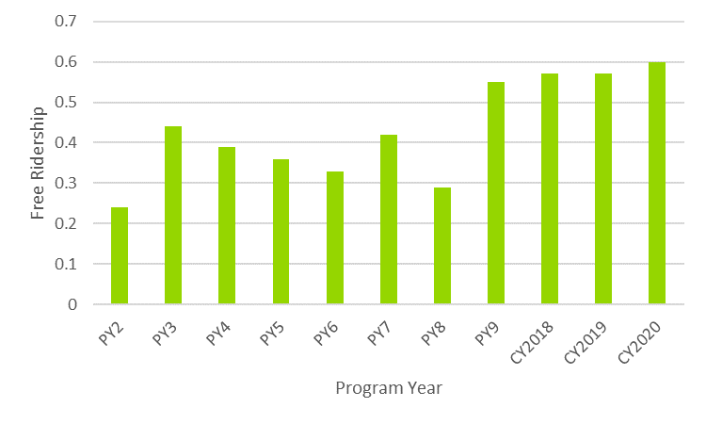

Source: Evaluation team analysis
As Figure 5 shows, Data Center FR has decreased since PY9. At that time, the program’s largest segment was new construction co-location projects with high FR. In 2018 and 2019, the program limited participation by new construction co-location projects. But again in 2020, the program developed several new construction projects for co-location data centers; however, these facilities reported lower free ridership than previous similar projects. The program should continue to seek out new construction co-location projects with the potential for high program influence.
Figure 5. Comparison of Data Center Project Evaluated Free Ridership over Program Years
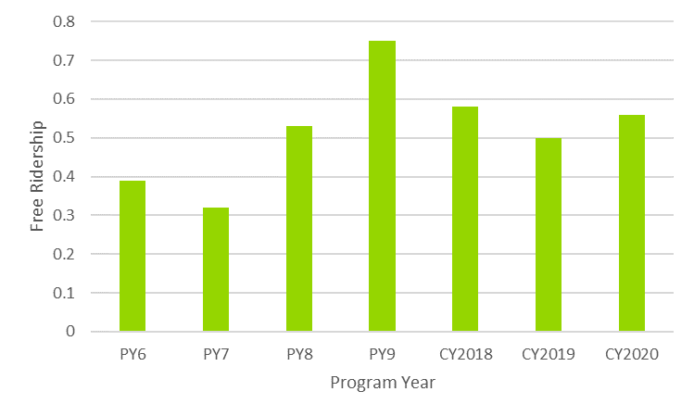

Source: Evaluation team analysis

Screening Projects with High Free Ridership
One way to assess a project’s likely rate of free ridership is to examine the key factors driving the project before the incentive is approved. For example:
- Has the project already been included in the capital or operating budget? Has the equipment already been ordered or installed?
- Is the measure one that the company or other comparable companies in the same industry or segment routinely installs as a standard practice? Is the measure now industry standard practice? Was the measure installed in other locations without an incentive?
- Is the project being done, in part, to comply with regulatory mandates (such as environmental regulations)?
- Are the project economics already compelling without incentives? Is the project payback short even without the incentive? Is the rebate large enough to make a difference in whether the project is implemented?
- Is the company in a market segment that is ahead of the curve on energy efficiency technology installations?
- Is it part of a national chain that already has a corporate policy to install the proposed technology?
- Does the proposed measure have substantial non-energy impacts? Is it being considered largely for non-energy reasons (such as improved quality or increased production)?
By conducting a brief customer interview regarding these issues before the incentive is approved, ComEd can better assess the likely degree of free ridership and may then decide if the project qualifies for an incentive or if it should be re-scoped to a higher efficiency level.

Custom Program NTG History
 | Business Custom Incentive
EPY1 | NTG 0.72  Free Ridership 28%  Spillover 0%  Method: Customer self-reports. 24 surveys completed from a population of 88.
EPY2 | NTG 0.76  Free Ridership 24%  Spillover 0%  Method: Customer self-reports. 20 surveys completed from a population of 345.
EPY3 | NTG 0.56 for kWh and 0.46 for kW  Free Ridership 44%  Spillover 0%  Method: Customer self-reports. 67 surveys completed from a population of 887.
EPY4 | Deemed using PY2 = 0.76  PY4 Research NTG 0.61 for kWh and 0.64 for kW  Free Ridership 39%  Spillover 0%  Method: Customer self-reports. 63 surveys completed from a population of 367.
EPY5 | Illinois SAG Consensus:  - 0.56
EPY6 | Illinois SAG Consensus:  - 0.61 kWh (deemed by Illinois SAG for PY6)  - 0.64 kW (deemed by Illinois SAG for PY6)  Values for kilowatt-hours and kilowatts are derived from PY4 evaluation research results and are based on the Illinois SAG-approved values.
EPY7 | Custom NTG: 0.64  Free Ridership: 0.36  Participants Spillover: Negligible  Nonparticipants Spillover: Negligible  Data Centers NTG: 0.48  Free Ridership 0.52  Participants Spillover: Negligible  Nonparticipants Spillover: Negligible  Source: Participant self-report telephone survey. The spillover effects were examined in this evaluation and their magnitude was found to be small as discussed below in the spillover section. Quantification of spillover was not included in the calculation of the NTG ratio for EPY5.  Notes: In PY5, Data Centers were combined with Custom, while in PY6, Data Centers were managed separately from Custom.  Interviews were completed with five of 11 Data Center projects.
EPY8 | Recommendation (based upon PY6 research):  Custom NTG: 0.67  Custom Free Ridership: 0.33  Custom Spillover: 0.005  NTG Research Source:  Free Ridership and Spillover: PY6 participant and vendor research
EPY9 | Custom NTG: 0.58  Custom Free Ridership: 0.42  Custom Spillover: Negligible  NTG Research Source:  Free Ridership and Spillover: PY7 participant and vendor research
CY2018 | Custom NTG kWh: 0.58  Custom NTG kW: 0.70  Custom Free Ridership kWh: 0.42  Custom Free Ridership kW: 0.30  Custom Spillover: Negligible  NTG Research Source:  Free Ridership: PY7 participant and vendor research  Spillover: PY7 participant self-report data  The evaluation team performed telephone surveys in PY8, but the analysis will be performed and combined with PY9 findings
CY2019 | Custom NTG kWh: 0.58  Custom NTG kW: 0.70  Custom Free Ridership kWh: 0.42  Custom Free Ridership kW: 0.30  Custom Spillover: Negligible  NTG Research Source:  Free Ridership and Spillover: PY7 participant and vendor research  The evaluation team performed telephone surveys in PY8, but the analysis will be performed and combined with PY9 findings.
CY2020 | Custom NTG kWh: 0.56  Custom NTG kW: 0.58  Custom Free Ridership kWh: 0.44  Custom Free Ridership kW: 0.42  Custom Spillover: Negligible  NTG Research Source:  CY2018 participating customer surveys
CY2021 | Custom NTG, All but Street Lights, Data Centers: 0.51  Custom NTG, LED Street Lights: 0.81  Custom Spillover: 0.00  NTG Research Source:  Values based on 2018 and 2019 Guidehouse participant research results.  Streetlights NTG from the Municipal streetlights in the LED Street Lights program
CY2022 | Custom NTG kWh: 0.36 kW: 0.26  Custom Free Ridership kWh: 0.64 kW: 0.74  Custom Spillover: Negligible  LED Streetlighting NTG kWh: 0.81 kW: 0.81  LED Streetlighting Free Ridership kWh: 0.19 kW: 0.19  LED Streetlighting Spillover: Negligible  NTG Research Source:  CY2020 participating customer surveys

Data Centers Program NTG History
 | Data Centers
EPY7 | Data Centers NTG: 0.48  Free Ridership 0.52  Participants Spillover: Negligible  Nonparticipants Spillover: Negligible  See EPY7 Custom program
EPY8 | Recommendation (based upon PY6 research):  Data Center NTG kWh: 0.60  Data Center NTG kW: 0.57  Data Center Free Ridership kWh: 0.40  Data Center Free Ridership kW: 0.43  Data Center Spillover: Negligible  NTG Research Source:  Free Ridership and Spillover: PY6 participant and vendor self-report data
EPY9 | Data Center NTG: 0.68  Data Center Free Ridership: 0.36  Data Center Spillover: Negligible  NTG Research Source:  Free Ridership and Spillover: PY7 participant and vendor self-report data
CY2018 | Data Center NTG kWh and kW: 0.68  Data Center Free Ridership kWh and kW: 0.32  Data Center Spillover: Negligible  NTG Research Source:  Free Ridership: PY7 participant and vendor self-report data  Spillover: PY7 participant and vendor self-report data  The evaluation team performed telephone surveys in PY8, but the analysis will be performed and combined with PY9 findings.
CY2019 | Data Center Co-Locations: New Construction NTG kWh and kW: 0.20  Data Center Co-Locations: New Construction Free Ridership kWh and kW: 0.80  Data Center Co-Locations Spillover: Negligible  Data Center Co-Locations: Retrofit NTG kWh and kW: 0.72  Data Center Co-Locations: Retrofit Free Ridership kWh and kW: 0.28  Data Center Co-Locations Spillover: Negligible  Data Center Non-Co-Locations NTG kWh and kW: 0.71  Data Center Non-Co-Locations Free Ridership kWh and kW: 0.29  Data Center Non-Co-Locations Spillover: Negligible  NTG Research Source:  Free Ridership: PY8 and PY9 participating customer surveys  Spillover: PY8 and PY9 participating customer surveys  The evaluation team performed telephone surveys in PY8, but deferred analysis until PY9.  The recommended values are based on the combined PY8/9 results.
CY2020 | Data Center Co-Locations, New Construction NTG kWh: 0.44  Data Center Co-Locations, New Construction NTG kW: 0.34  Data Center Co-Locations, New Construction Free Ridership kWh: 0.56  Data Center Co-Locations, New Construction Free Ridership kW: 0.66  Data Center Co-Locations Spillover: Negligible  Data Center Co-Locations, Retrofit NTG kWh: 0.78  Data Center Co-Locations, Retrofit NTG kW: 0.82  Data Center Co-Locations, Retrofit Free Ridership kWh: 0.22  Data Center Co-Locations, Retrofit Free Ridership kw: 0.18  Data Center Co-Locations Spillover: Negligible  Data Center Non-Co-Locations NTG kWh and kW: 0.67  Data Center Non-Co-Locations Free Ridership kWh and kW: 0.33  Data Center Non-Co-Locations Spillover: Negligible  NTG Research Source:  Free Ridership: CY2018 participating customers survey  Spillover: CY2018 participating customers survey
CY2021 | Co-location New Construction kWh: 0.43  Co-location New Construction Free Ridership kWh: 0.57  Co-location New Construction Spillover: Negligible  Data Center Other Projects kWh: 0.72  Data Center Other Projects kWh: 0.28  Data Center Other Projects Spillover: Negligible  NTG Research Source:  CY2019 participating customer surveys
CY2022 | New Construction kWh: 0.46 kW: 0.75  New Construction Free Ridership kWh: 0.54 kW: 0.25  New Construction Spillover: Negligible  Retrofit kWh: 0.38 kW: 0.30  Retrofit Free Ridership kWh: 0.62 kW: 0.70  Retrofit Spillover: Negligible  NTG Research Source:  CY2020 participating customer surveys
https://ilsag.s3.amazonaws.com/ComEd-NTG-History-and-CY2021-Recs-2020-09-30-Final.pdf

The LED Streetlighting projects are unique large projects that merit separate reporting. The SAG approved deemed savings for this measure from the LED Streetlighting Program was used for these projects in the custom program.
Co-location is the practice of housing privately-owned servers and networking equipment in a third-party data center.
Only two of the 16 projects in the population are non co-location projects, so the evaluation team did not stratify co-location vs non co-location projects as in previous years.
One completed project was removed from the sample as the interview was completed by the program vendor instead of the decision maker.
Projects where NTG research was conducted during an earlier phase are referred to as legacy projects. These are generally phased projects where the incentive payment has been broken into multiple components and is paid out over more than one program year. For these projects, decision makers were contacted to verify that the responses from the previous evaluation cycle(s) still apply. In all cases, the decision maker confirmed that they do. As a result, the interview results and NTG ratios from the previous phase(s) apply to the current year’s analysis.
These values are based on the researched program year and thus differ from the deemed values in the appendices.
These values are based on the researched program year and thus differ from the deemed values in the appendices.

