To: | Erin Daughton, ComEd
CC: | Rick Berry, Cherlyn Seruto, Rob Neumann, Jeff Erickson, Randy Gunn; Navigant  Jennifer Morris, ICC
From: | Sharon Mullen, Charles Ampong, Navigant
Date: | January 14, 2020
Re: | ComEd Standard T12 Baseline and Early Replacement of Fluorescent Tube Lighting

Executive Summary

This memo represents our research on fluorescent tube lighting in commercial facilities throughout the ComEd territory and updates our preliminary findings memo issued in August 2019. The preliminary findings memo was issued to inform a Stakeholder Advisory Group (SAG) discussion on early replacement of fluorescent tube lighting and the T12 baseline, and was based on early survey results from 21 respondents who had addressed fluorescent tube lighting in their Standard projects.

The survey was designed to conduct net-to-gross (NTG) research of the Standard Offer, with modules to research the lighting topics. We continued fielding through the fall, completing 338 surveys. We present findings on the following categories:

- Continued use of fluorescent tube lighting in commercial facilities
  - As reported by 190 Standard Offer participants to establish a baseline
- Actions and motivations of participants
  - As reported by 39 Standard Offer participants who addressed fluorescent tube lighting in their project.

Findings and Recommendations
Finding 1. A majority (56%) of facilities continue to use fluorescent tube lighting. T12s represent a small fraction of fluorescent tube lighting in use, with 28% of facilities able to identify using T8s exclusively, and 5% using T12s exclusively. When T12 lamps are used in combination with other fluorescent tubes, 43% of the facilities use T12s in less than 10% of their tube fixtures.

Finding 2. A majority of facilities using the lamps hold replacement stock, with 75% of facilities having T12 replacement stock on-hand, and 80% having T8 replacement stock on-hand.

Finding 3. T12s will be replaced with LED technology when the lamps fail in 45% of the facilities and 50% of facilities when ballasts fail. Eighteen percent of facilities will retrofit failed T12 ballasts with T8s, and 15% will retrofit T12s upon lamp burnout with T8s. Forty seven percent of facilities will replace T8s with LEDs upon burnout.
Recommendation 1. Engage with customers by addressing their needs, including expanded financial metrics to develop a business case for energy efficiency projects.

Finding 4. The Standard Offer and its incentives motivated participants to upgrade their lighting.

Finding 5. The majority of T12 lamps were working when they were replaced through a project.
Recommendation 2. Engage with customers prior to exhaustion of on-hand replacement stock.

Existing Fluorescent Tube Lighting (Baseline)
This research was conducted of Standard participants who participated in the program and reported that they had fluorescent tube lighting in their facilities but did not address the tube lighting in their projects.

Commercial Facilities Using Fluorescent Tube Lighting
We surveyed 338 Standard participants to conduct net-to-gross (NTG) research of the offer, shown in Figure 1. One hundred ninety, or 56%, of the respondents reported that their facilities continue to use fluorescent tube lighting and contributed to this baseline research. Of these, 105 implemented projects between July 2018 – July 2019, while 85 implemented projects between July 2017- June 2018.

Figure 1. Standard NTG Survey Respondents Reporting Use of Fluorescent Tube Lighting
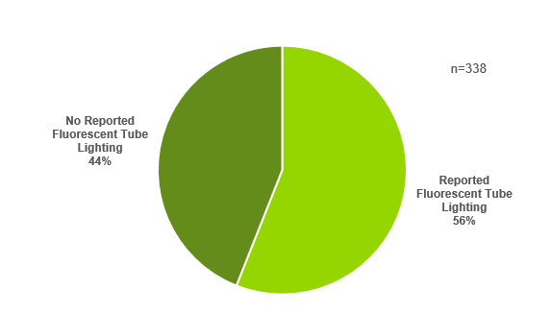
Source: Navigant research and analysis of ComEd data

The 190 participants reporting fluorescent tube lighting in their facilities implemented both lighting and non-lighting projects. While 34% of these projects implemented only lighting measures, these projects did not address existing fluorescent tube lighting.

Installed Types of Fluorescent Tubes
Respondents identified the fluorescent tube lighting in their facilities as T12, T8 or “Other.” Thirty two percent reported that they had only one type of lamp, and 46% reported multiple types of lamps installed. Twenty two percent (40 respondents) could not identify the type of lamp. When respondents reported one lamp type, 70% had T8s installed, as shown in Figure 2. Similarly, when multiple lamp types are installed, the highest percentage of lamps in use was also T8s.

Figure 2. Reported Lamp Types Installed
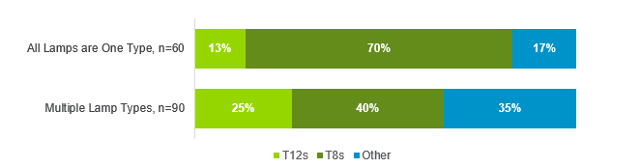
*Excludes those who did not know what type of lamps were installed.
Source: Navigant research and analysis of ComEd data

Our baseline research focused on those participants who reported continued use of T12 and T8 lamps. Forty percent of the respondents reported using T12s, either exclusively or as one of multiple lamp types, and 81% reported using T8s in their facilities.

T12s represent a small fraction of fluorescent tube lighting in use, with 5% using T12s exclusively, compared to 28% using T8s exclusively. A majority of those using more than one type of fluorescent lamp in their facility, 60%, do not use T12s. When T12 lamps are used in combination with other fluorescent tubes, 43% of the facilities use T12s in less than 10% of their tube fixtures, as shown in Figure 3.

Figure 3. Percentage of T12s When Used with Other Fluorescent Tubes
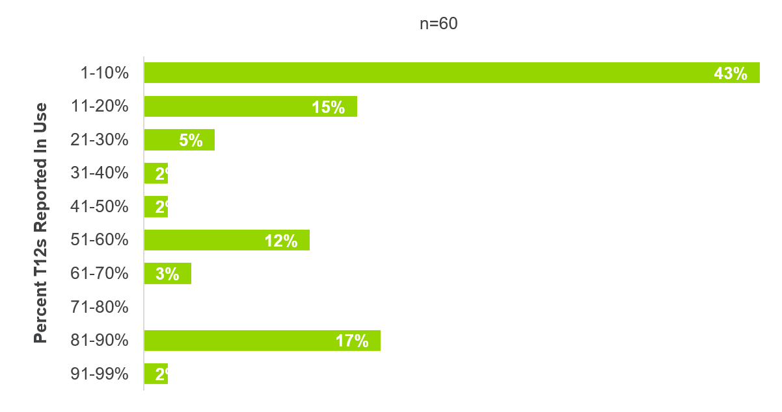
Source: Navigant research and analysis of ComEd data

Respondents reporting that T12s or T8s are used in their facility are spread across multiple industry segments with the largest populations coming from Professional Services and Manufacturing, as shown in Figure 4.

Figure 4. Distribution of Lamps by Industry Segment
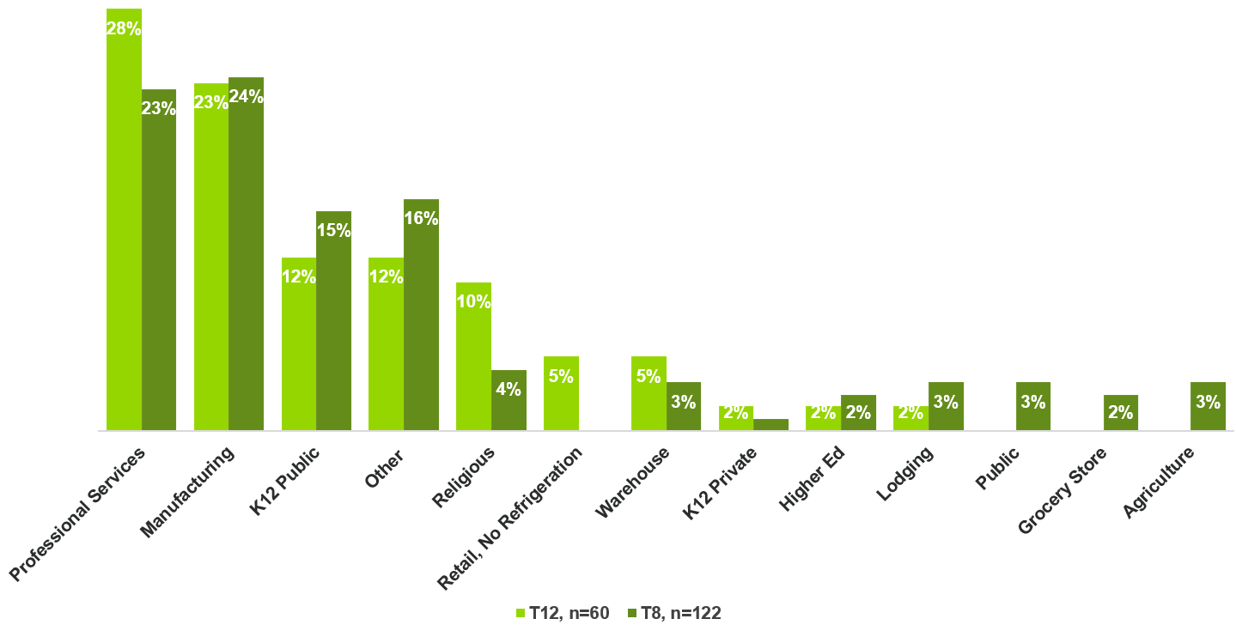

Source: Navigant research and analysis of ComEd data

Action Upon Failure
The majority of facilities using fluorescent tube lighting also have replacement stock on-hand (75% of those with T12s and 80% of those with T8s). The replacement stock will last for different time spans, as shown in Figure 5. The T8 stock will be depleted more quickly than the T12 stock. Forty three percent of T8 stock will last less than six months, while 38% of the T12 will last longer than one year.

Figure 5. Estimated Time to Deplete On-Hand Replacement Stock
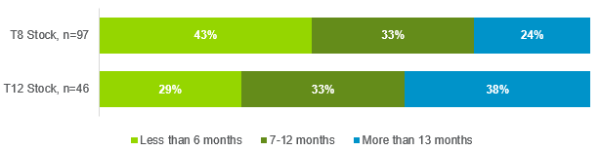

Source: Navigant research and analysis of ComEd data

T12s will be replaced with LED technology when the lamps fail in 45% of the facilities and 50% of facilities when ballasts fail. Eighteen percent of facilities will retrofit failed T12 ballasts with T8s, and 15% will retrofit T12s upon lamp burnout with T8s, as shown in Figure 6.Thirty seven percent will replace failed lamps with T12s, and 23% will replace failed ballasts with T12 ballasts.

Figure 6. Action Upon Existing T12 Lamp or Ballast Failure
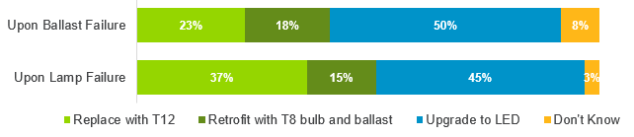

Source: Navigant research and analysis of ComEd data

Forty seven percent of facilities will replace T8s with LEDs upon burnout, as shown in Figure 7.

Figure 7. Action Upon Existing T8 Lamp or Ballast Failure
Source: Navigant research and analysis of ComEd data

Participant Motivation to Reengage
The survey asked participants about their decision-making process to engage in projects that address systems other than those they already implemented in their original projects. Survey respondents with fluorescent tube lighting in their facilities seek a variety of information to reengage with the offer and start another project to a different measure type. Most often cited when asked “what prevented them from addressing multiple other systems in their energy efficient projects” was the need for additional financial metrics associated with the projects, followed by additional information about energy efficiency opportunities, as shown in Figure 8.

Figure 8. Concerns Preventing Participants from Addressing Additional Systems in EE Projects
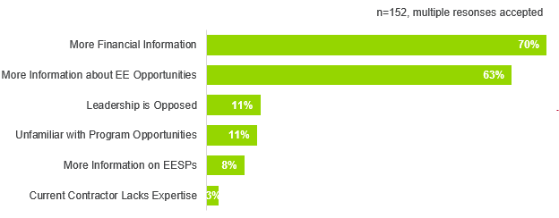

Source: Navigant research and analysis of ComEd data

Respondents offered specific motivators to reengage with the offer, shown in Figure 9. The survey asked “anything else that would help your company engage in these other energy efficient projects in the future.” Twenty four percent of the respondents volunteered what they would like to see from ComEd to help them reengage with the offer. More program information, greater incentives were most commonly mentioned, followed by more financial information.

Figure 9. Additional Motivation to Reengage with Offer
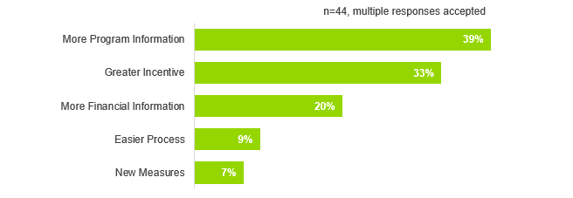

Source: Navigant research and analysis of ComEd data

Participants who Addressed Fluorescent Tube Lighting in their Standard Projects
Participants who addressed fluorescent tube lighting in their Standard projects were asked a suite of questions designed to understand the program’s influence on their decision to participate in the offer and their motivation to advance the energy efficient projects.

Commercial Facilities That Addressed Fluorescent Tube Lighting
Navigant surveyed from a sample that included 400 projects where T12 lighting were replaced, and completed surveys with 39 of those participants. Of these, 30 completed their projects between July 2018 – July 2019, and nine completed their projects during the prior twelve months.

Over 95% reported replacing existing working equipment, with the majority replacing outdated equipment, shown in Figure 10.

Figure 10. Status of Existing Equipment When Replaced
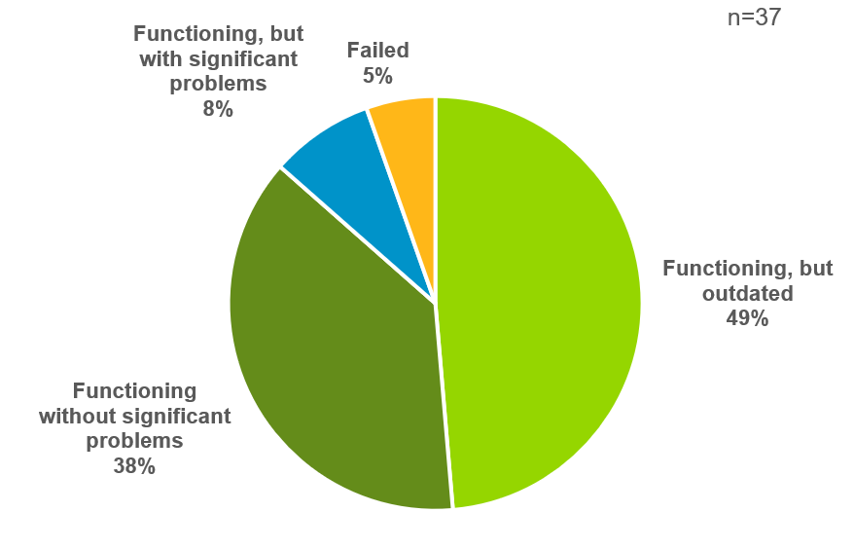
Note: This figure excludes two “don’t know” responses.
Source: Navigant research and analysis of ComEd data

The respondents were from a variety of industry segments. Those segments with two or more respondents are shown in Figure 11. Professional Services composed the largest segment, followed by Religious facilities, Manufacturing and Education.

Figure 11. Respondent Industry Segments
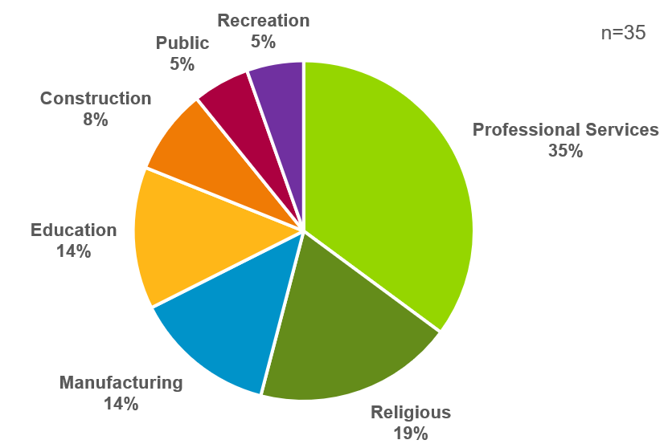
Note: Segments represented only when two or more respondents identified a segment.
Source: Navigant research and analysis of ComEd data

A closer look at the respondents showed variation in the status of their equipment by industry segment, with religious facilities and manufacturing waiting until equipment failed, and professional services most likely to upgrade prior to experiencing issues, shown in Figure 12.

Figure 12. Status of Existing Equipment Prior to Replacement, by Industry Segment
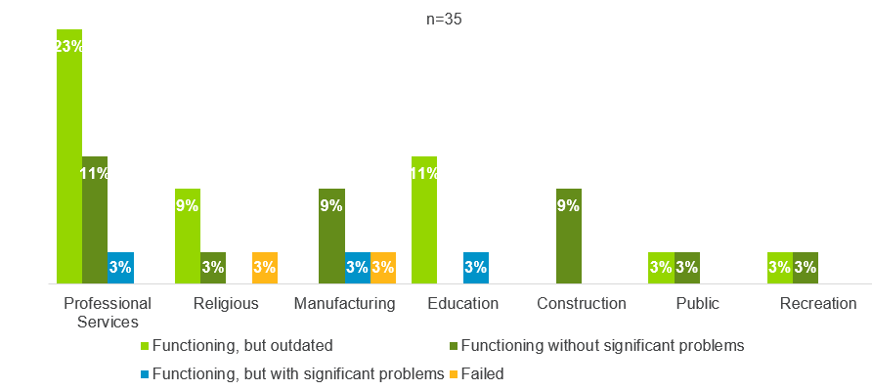
Note: Segments represented only when condition questions were answered, and two or more respondents identified a segment.
Source: Navigant research and analysis of ComEd data

The majority of respondents, 78%, own their facility, with the breakdown by industry segment offered in Figure 13.

Figure 13. Facility Ownership Status, by Industry Segment
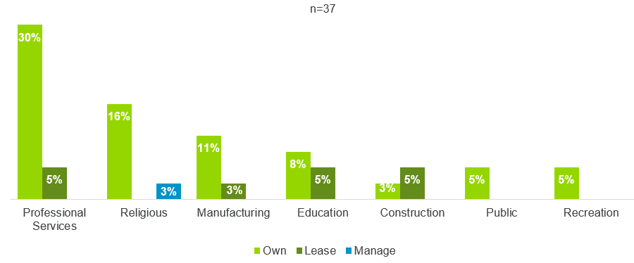

Note: Segments represented only when two or more respondents identified a segment.
Source: Navigant research and analysis of ComEd data

Motivation to Upgrade Fluorescent Tube Lighting
The primary motivation to upgrade lighting was to save energy or the money spent on energy, reported by all segments other than manufacturing, shown in Figure 14.

Figure 14. Motivation to Replace Existing Equipment, by Industry Segment
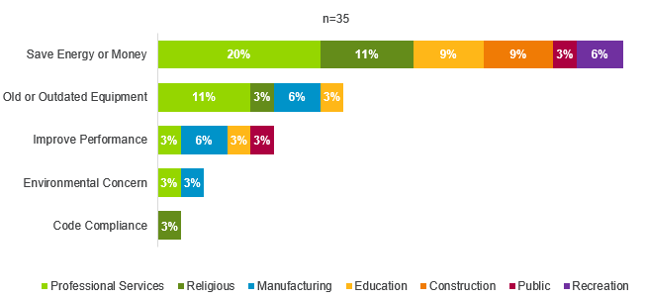
Note: Segments represented only when two or more respondents identified a segment.
Source: Navigant research and analysis of ComEd data

Without the program, 47% respondents would not have improved their fluorescent tube lighting. Another 47% would have replaced the fluorescent tube lighting with LED tubes or new LED fixtures, shown in Figure 15.

Figure 15. Action without Standard Offer, by Industry Segment
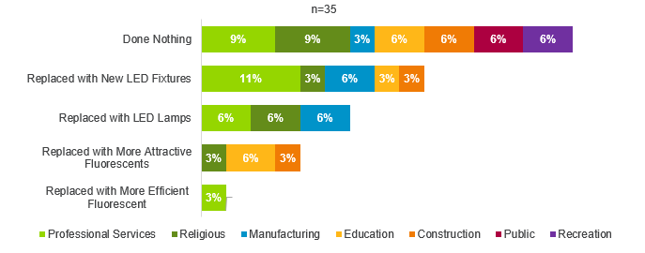
Note: Segments represented only when two or more respondents identified a segment.
Source: Navigant research and analysis of ComEd data

Navigant, “Preliminary Findings from Standard and Instant Discount Participant Surveys on Early Replacement of Tube Lighting and the T12 Baseline,” August 19, 2019.

