Proposal from MEEA/RI to be Reviewed by Midwest Market Transformation Collaborative
Ideas on External Outreach Strategy
Draft 7/16/2020

This document describes how the Midwest Market Transformation Collaborative (MW MTC) will engage stakeholders and external entities in states across the Midwest. The intent is to:
- Ensure interested entities understand the goals and work of the MW MTC.
- Instigate a process for updating stakeholders over time and soliciting their input.
- Develop a process for stakeholders to submit Market Transformation (MT) ideas for consideration.

- (Startup) Inform Stakeholders on the Goals and Work of the MW MTC
The MW MTC will host a virtual meeting in Q3/Q4 2020 to brief stakeholders on the MW MTC, outline activities to date and review identified potential MT opportunities and in-progress (if applicable) initiatives. These include but are not limited to:

- Luminaire Level Lighting Controls
- Electric Heat Pump Water Heaters
- Commercial Food Service
- Illinois Code Compliance
- Thin Triple Pane Windows
- Commercial Window Attachments - Secondary Glazing Systems
- Residential Low-E Interior Storm Windows
- Retail Products Platform (RPP)
- Gas Heat Pump Water Heaters
- Next Generation Refrigerators

The meeting is intended to be an open-forum and attendees will be encouraged to ask questions and provide comments. The invitation list will be informed by utility members of the MW MTC, participants in state/utility stakeholder groups and additional organizations throughout the Midwest.

- Annual Update for Stakeholders
After the initial briefing, the MW MTC will hold annual webinars to update stakeholders on progress and the status of work. Questions and comments will be encouraged during this webinar.

- MT Idea Submission
The MW MTC wants to ensure that stakeholders have the opportunity to provide ideas that could evolve into market transformation efforts. Ideas will be solicited annually.

It will be important for proposers to know that each utility has unique budget constraints and planning cycles that must be considered which may constrain new investments by utilities in MT. However, ideas that score highly as MT initiatives will be kept in a pipeline for potential adoption as opportunity arises.

3a. Idea Submission Process:
- Prior to each solicitation, the MW MTC will host a call to explain the goal and discuss the MT criteria against which the idea will be judged. In addition, the staff will provide information on the planning cycle for each utility in the MW MTC, since opportunities at the beginning of a planning cycle may be greater than in the middle of the planning cycle. Staff will also make clear that there is no guarantee of a proposal moving forward.

- Proposers will fill out a form (likely done online) outlining the proposed market and technology and describing key market transformation characteristics.

- Staff from the MW MTC will follow up with proposers to clarify the proposal and ask questions.

- Staff will work with the utilities in the MW MTC to decide whether any of them want to:
  - Start a new initiative
  - Develop research steps to investigate the idea further
  - Put on a list of longer-term pipeline ideas
  - Decline the proposal
Staff can also review the proposals and score them based on MT and overall portfolio criteria in advance of the MW MTC’s discussion.

- Once the MW MTC has decided the status of the proposed ideas, staff will review the results with stakeholders, preferably in the annual update meeting, but in a stand-alone meeting if needed.

  - Each proposer will be notified of the outcome for their proposal in advance of the public meeting.

Illinois Specific Considerations
The question of stakeholder engagement in MT initiatives came at the May 19, 2020 meeting of the Illinois Stakeholder Advisory Group’s (“IL SAG”) Market Transformation Savings Working Group (MT WG). The MT WG’s specific questions are shown below.

This section specific to IL is included in this external outreach strategy to give other states an idea of the types of issues that could arise and would likely need to be addressed specific to that state’s/utility’s processes.

- How will non-utility stakeholders have the opportunity to provide feedback on which initiatives move forward?
The process of developing an MT initiative through the MW MTC typically involves the three stages depicted in Figure 1.

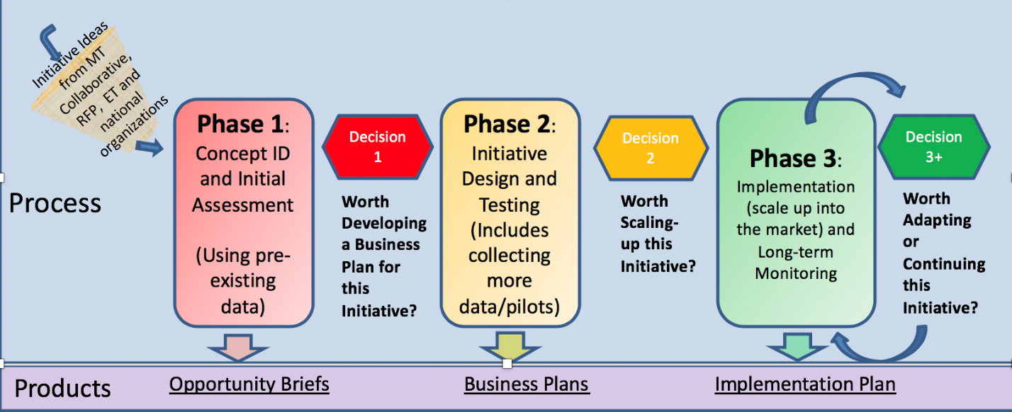
Figure 1: MT initiative Stage Gate Process
An Opportunity Brief (or similar information) will be presented to the SAG MT Working Group (MT WG) at the time a utility or group of utilities elect to move forward with the development of a Business Plan (BP) at decision point 1. The BP will then be developed based on input from the MT WG, and when near completion, it will be presented at an MT WG meeting for input. Based on that input, utilities will decide whether to move forward to implementation and revise the BP (if needed).
- Who will implement MT initiatives?
Once the BP is developed, an implementation plan follows, which becomes the basis for the statement of work, schedule, and budget to implement the initiative. Funders of initiatives will decide whether implementation (or parts of implementation) is conducted jointly among the funders or conducted individually by each utility and also if/how and when to bid out implementation tasks. In some cases, there might be obvious organizations who are uniquely suited to either administer or deliver the implementation, at the discretion of the utility funders.
- How will non-utility stakeholders be able to provide feedback on initiatives as they evolve?
The annual update webinar proposed in the MW MTC “External Outreach Strategy” provides opportunity for stakeholder feedback on existing initiatives and those in the pipeline. In addition, it is likely that updates will be delivered at SAG MT WG meetings periodically.

- How are the natural market baselines and savings estimates being developed (from a process perspective)? Who is involved in that process and what does it look like? What is the role of non-utility stakeholders?
Natural Market baseline Development and Review: Natural Market Baselines are an integral part of developing a Business Plan (BP). They are developed by the entity writing the BP using either existing information or through additional research. The BP is presented to the MT WG.
Non-utility stakeholders will review the natural market baseline at the time the BP is presented to state/utility stakeholders.
In should be noted that Attachment C of the IL TRM recommends that evaluators be consulted to review methods and recommendations on natural market baseline and savings before the BP is released. This is an important part of developing savings estimates for the BP.
Per-unit Savings Development: The BP will also indicate the per-unit savings that are proposed to be used for that initiative. These savings may come from various sources, including the IL TRM. However, in many cases the technologies in the BP may not yet exist in the TRM. If this is the case, the best information available will be documented in the BP, and utilities can propose any needed follow-up activities to improve the estimates, including the possibility of executing a workpaper for inclusion in the TRM. Savings estimates are part of the review by evaluators before release of the BP.
- What if there is not consensus on the natural market baseline or the savings per unit?
Natural Market Baseline: If there is no consensus among parties who do not have a conflict of interest on the natural market baseline, a plan will be developed that is agreeable to the parties to address the contentious issues. The discussion at the MT WG will include whether the stakeholders can support the utility(ies) moving forward with the initiative in the meantime, taking into consideration that savings are sometimes a small part of the first few years of an initiative.

Savings per unit: The same approach will be taken as described in the NMB.

- After a Natural Market Baseline (NMB) is in place, what is the process for considering and adopting prospective modifications?
New data and market conditions may arise while a market transformation initiative is being pursued that will impact the forecasted natural market baseline. Examples of these appear in section 2.2.2.3 of Attachment C of the IL TRM. In such cases, utilities operating the initiative can raise the need for an adjustment and bring the recommendation to MT WG for input. In addition, participants in the MT WG can request the utility review the natural market baseline anytime they become aware of new data or market conditions that could influence the NMB forecast.
- After a budget is in place, what is the process for significant budget changes?

Budget changes that are intentional planning decisions on the part of the utility (not caused by unexpectedly low or high participation) in excess of 50% for MT-funded initiative budgets under $5 million or 20% for MT-funded initiative budgets over $5 million will be brought to the SAG when practicable, but no later than the next quarterly SAG meeting. These thresholds were taken from the IL Policy Manual for non-MT programs.

- Beyond natural market baseline and budget, how does a change to an initiative happen and how do stakeholders find out?
Initiative progress/changes will be reviewed at the annual update webinar proposed in the MW MTC’s “External Outreach Strategy”.
- Public Availability of MT documents
Opportunity Briefs and Business Plans reviewed by MT WG will be made available through the Illinois SAG Market Transformation Savings Working Group webpage, and on any website that is developed for the MW MT. Any confidential or proprietary information will be redacted.

Note that proprietary information will not be accepted during the solicitation process. If the initiative is of interest, non-disclosure agreements will need to be put in place to collect further information.
Insert reference to TRM
An alternative might be to constitute an impartial group of energy efficiency experts (like from ACEEE, DOE, others?) to review the materials and decide.
Accessed here: https://www.ilsag.info/mt_savings_working_group/

